BUG 1:

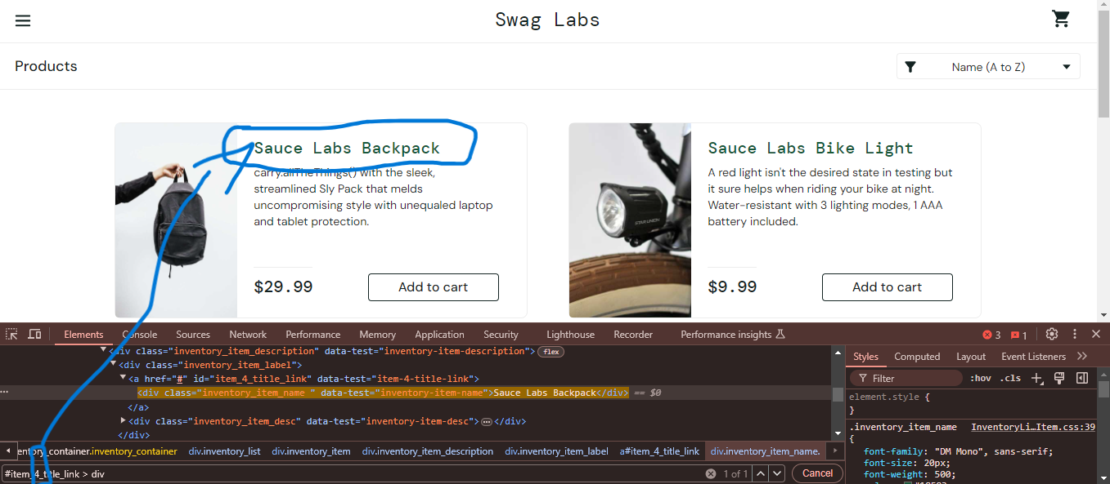

Products not arrenging perfectly. For example use for css selector number is 4, but the product

Is arrenged in first place.

BUG 2:

Product not open new window. Opened for current window.

BUG 3:

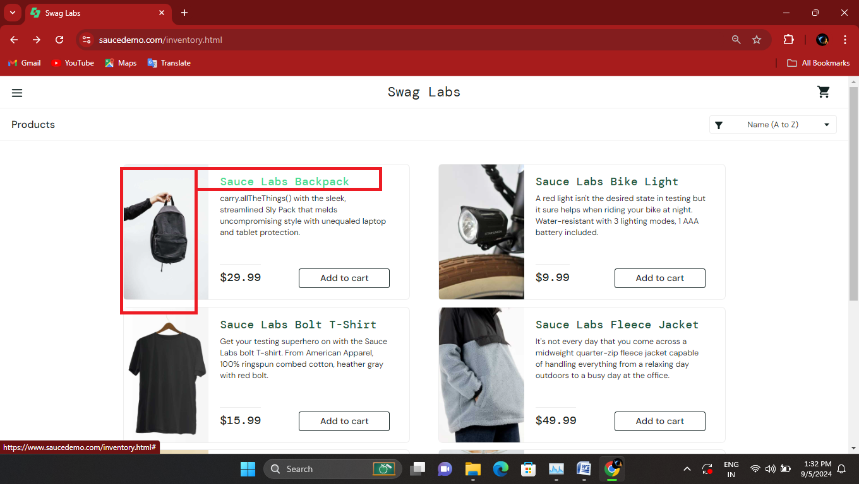

Product clickable not efficient, only click for red marked places. Many places not clickable.

**Resolve:**

**Bug 1:**

Use for ID tag, in the div tag, and properly arranged items.

**Bug 2:**

Click product open in new window, don’t open in current window.

**Bug 3:**

I click one item, but some places not clicked, so change to clickable

for item in border to border